**Question 1**

**Draw a relational schema diagram specifying the foreign keys for this schema.**

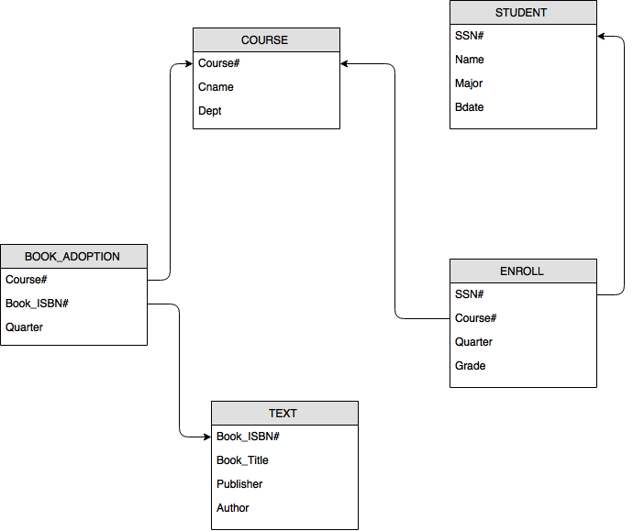

**Question 2**

1. **Normalize that table structure to the first, second and third normalization forms**
2. The first normalization form

|  |  |  |
| --- | --- | --- |
| **Cust#** | **Name** | **Addr** |
| 43 | Jones | 121 1st |
| 55 | Smith | 222 2nd |

|  |  |  |
| --- | --- | --- |
| **Product#** | **Part** | **Amt** |
| 01 | Screw | 2.00 |
| 02 | Motor | 52.00 |
| 03 | Saw | 121.00 |
| 04 | Nut | 2.25 |
| 05 | Brace | 44.44 |
| 06 | Washr | 0.75 |

|  |  |  |  |  |  |  |  |
| --- | --- | --- | --- | --- | --- | --- | --- |
| **Invoice#** | **Cust#** | **Product1** | **Quant1** | **Product2** | **Quant2** | **Product3** | **Quant3** |
| 1001 | 43 | 01 | 200 | 04 | 300 | 06 | 100 |
| 1002 | 55 | 02 | 1 | 05 | 5 |  |  |
| 1003 | 43 | 03 | 10 |  |  |  |  |

1. The second normalization form

|  |  |  |
| --- | --- | --- |
| **Cust#** | **Name** | **Addr** |
| 43 | Jones | 121 1st |
| 55 | Smith | 222 2nd |

|  |  |  |
| --- | --- | --- |
| **Product#** | **Part** | **Amt** |
| 01 | Screw | 2.00 |
| 02 | Motor | 52.00 |
| 03 | Saw | 121.00 |
| 04 | Nut | 2.25 |
| 05 | Brace | 44.44 |
| 06 | Washr | 0.75 |

|  |  |  |  |
| --- | --- | --- | --- |
| **Invoice#** | **Cust#** | **Product#** | **Quant** |
| 1001 | 43 | 01 | 200 |
| 1001 | 43 | 04 | 300 |
| 1001 | 43 | 06 | 100 |
| 1002 | 55 | 02 | 1 |
| 1002 | 55 | 05 | 5 |
| 1003 | 43 | 03 | 10 |

1. The third normalization form

|  |  |  |
| --- | --- | --- |
| **Cust#** | **Name** | **Addr** |
| 43 | Jones | 121 1st |
| 55 | Smith | 222 2nd |

|  |  |  |
| --- | --- | --- |
| **Invoice#** | **Cust** | **Total Cost** |
| 1001 | 43 |  |
| 1002 | 55 |  |
| 1003 | 43 |  |

|  |  |  |
| --- | --- | --- |
| **Product#** | **Part** | **Amt** |
| 01 | Screw | 2.00 |
| 02 | Motor | 52.00 |
| 03 | Saw | 121.00 |
| 04 | Nut | 2.25 |
| 05 | Brace | 44.44 |
| 06 | Washr | 0.75 |

|  |  |  |
| --- | --- | --- |
| **Invoice#** | **Product#** | **Quant** |
| 1001 | 01 | 200 |
| 1001 | 04 | 300 |
| 1001 | 06 | 100 |
| 1002 | 02 | 1 |
| 1002 | 05 | 5 |
| 1003 | 03 | 10 |

1. **Draw relational schema diagram for the tables defined in the third normalization form above**

